Support for Equity Definitions VE v2.0 in FpML 5.14
ISDA FpML Cross Asset Product Working Group
September 2026 – TR (Final Implementation)

This document provides business context and high-level explanations for concepts introduced in v2.0 of the 2002 ISDA Equity Derivatives Definitions (Versionable Edition) (the “Equity Definitions VE”) and is intended for representation in FpML. All fields being proposed in this document are not mandatory from a transaction documentation perspective – they will only apply to the transaction if the parties elect them in the confirmation, in line with the approach taken in the Equity Definitions VE. The features introduced in v2.0 of the Equity Definitions VE are industry-standard methods of catering for index events, single share and basket valuation mechanics, Depository Receipts mechanics, and benchmark regulatory frameworks. These definitions explain what the provision is meant to achieve, why it exists, and how it behaves contractually.

Please note that these elements are optional for the parties to elect in the transaction documentation. If they are not specified, the corresponding features will be considered not applicable.

Disclaimer
This document is provided for the purpose of supporting representation in FpML. It is not intended to constitute, and should not be relied upon as, legal advice, and does not replace or amend the contractual terms of any transaction. Parties should refer to the applicable ISDA documentation and seek their own legal advice where appropriate.
Contents
1 Consequences of Non-Commencement or Discontinuance of the Exchange-traded Contract 3
2 VWAP VE and TWAP VE 6
3 Separate Valuation/Combined Calculation 8
4 Benchmark Provisions 10
5 Full DR Lookthrough and Partial DR Lookthrough provisions 12
6 Appendix 13

Consequences of Non-Commencement or Discontinuance of the Exchange-traded Contract

Equity Definitions VE Confirmation extract:
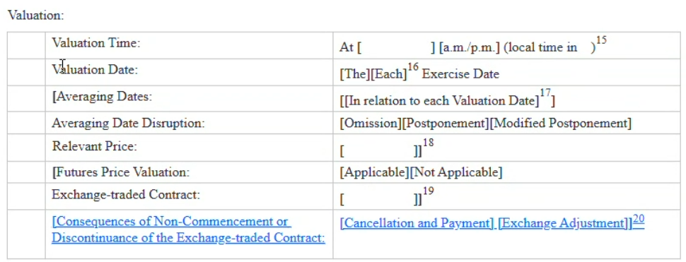
Consequences of non-commencement or discontinuance of the exchange-traded contract used for valuation are expanded in v2.0 of the Equity Definitions VE to include two added consequences, which can also apply to share transactions, in addition to index transactions.
Business context
- The 2002 Equity Definitions (published in 2002) stated that if no official settlement price of the exchange-traded contract exists because trading in the exchange-traded contract never commenced or has been permanently discontinued prior to a Valuation Date, the official settlement price will be the level of the relevant index at the close of the regular trading session on the relevant exchange on the valuation date.
- Equity Definitions VE v2.0 expanded the concept of futures price valuation to cover share transactions, such that both index transactions and share transactions can reference a futures or options contract for valuation.
- Equity Definitions VE v2.0 provide for two new consequences for situations where the exchange-traded contract does “not commence” trading or is “discontinued” before the valuation date.
- Parties can elect between:
  - Cancellation and payment – trade maturity is effectively accelerated, a final payment amount is determined by calculation agent, and a final payment is made.
  - Exchange adjustment – the calculation agent follows the exchange’s adjustments made to the contract and continues the transaction on the adjusted basis, or the transaction terminates (in line with Cancellation and Payment) if the exchange does not communicate such adjustments within a reasonable period.

FpML schema:
A new element nonCommencementOrDiscontinuation within the equityValuation & valuationRules structure.
XAPWG agreed on the selected attribute among the following choices –
- nonCommencementOrDiscontinuation
XAPWG further recommends ensuring that the description makes it explicitly clear - such feature is only applicable for Exchange Traded Contracts valuation purposes.

Close to the choice, as a sequence - ((futuresPriceValuation | optionsPriceValuation)?, nonCommencementOrDiscontinuation?)
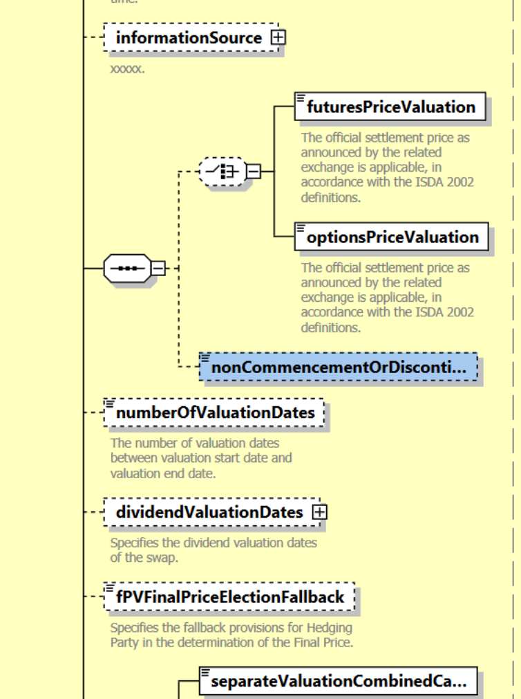

Valid Values/Enumerations:
  - CancellationAndPayment
  - ExchangeAdjustment
Example: 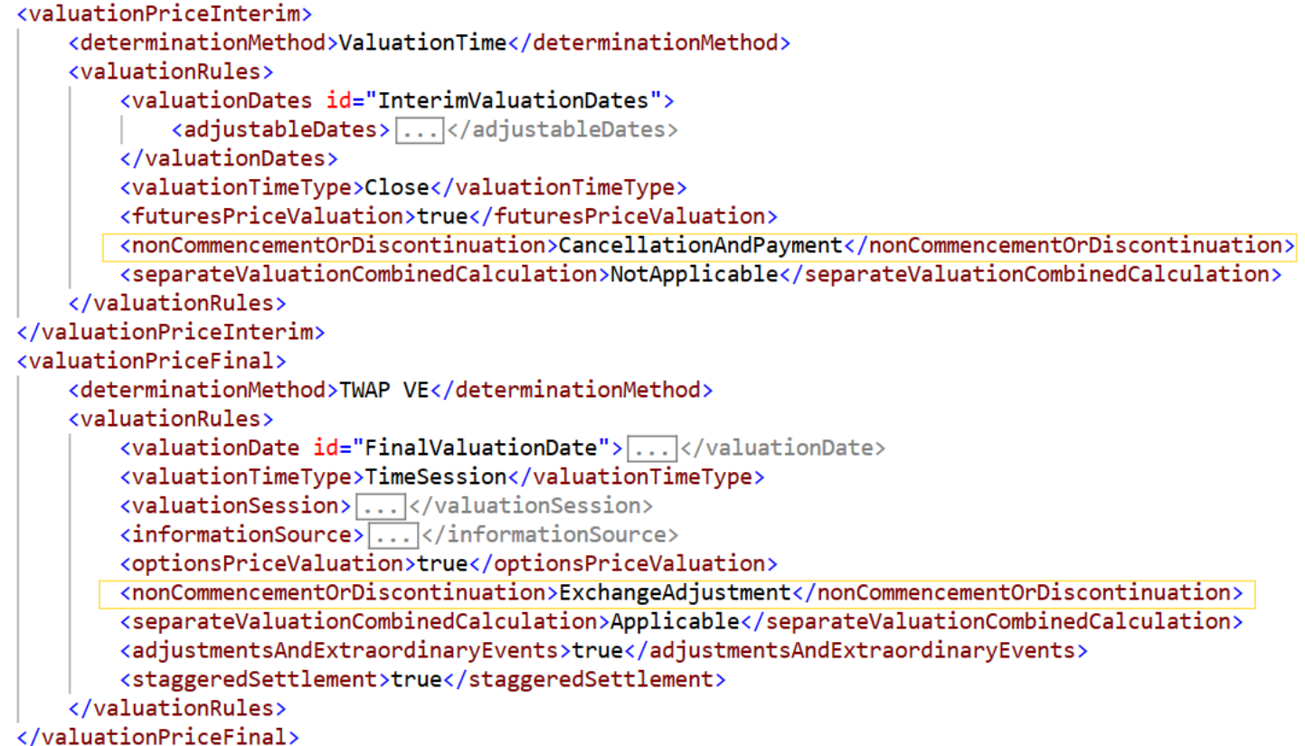

Applicability Condition
Only applicable when:
EITHER futuresPriceValuation = true OR optionsPriceValuation = true
New validation rules for business operations are set to be implemented.

Product scope:
The phrase nonCommencementOrDiscontinuation applies to all equity products because each one has its own valuation mechanism. The features listed in the future support section are excluded because they are beyond the scope of Equity Definitions VE.
Rationale for including it in 2 elements -
- equityExercise / equityValuation is applicable for Products - brokerEquityOption, equityForward, equityOption, equityOptionTransactionSupplement
- valuationRules is applicable for equity swaps (both ReturnSwap and EquitySwapTransactionSupplement)
Future support
When developing new products, it is important to take this feature into account as part of the Equity Definitions framework. Development efforts at this stage should focus exclusively on Options, Swaps, and Forwards.
correlationLeg,
varianceLeg (defined in VarianceSwapTransactionSupplement complexType),
varianceLeg (in varianceSwap),
volatilityLeg (in volatilitySwap),
volatilityLeg (in volatilitySwapTransactionSupplement) / valuation (EquityValuation)

VWAP VE and TWAP VE

Equity Definitions VE Confirmation extract:
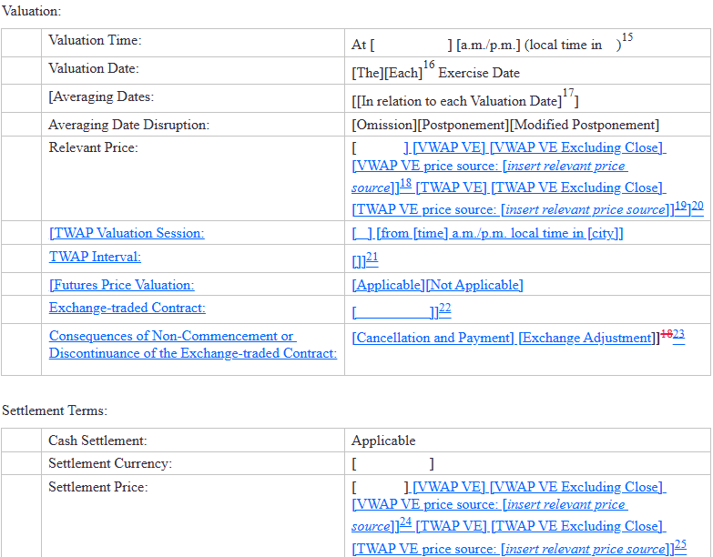
Business context
- VWAP VE (Volume-Weighted Average Price): calculates the price as a volume-weighted average of intra-day prices. VWAP VE Excluding Close is an alternative where the closing auction is excluded from computations.
- TWAP VE (Time-Weighted Average Price): calculates the price as a time-weighted average of prices observed at one-minute intervals during the valuation session. Like above, TWAP VE Excluding Close is an alternative where the closing auction is excluded from computations.
- TWAP VE also additionally allows session-based computations:
  - Specification of a valuation session (defaulting to regular trading hours, excluding the closing auction if TWAP VE Excluding Close is elected, or during bespoke time window).
  - Specification of the interval (if other than 1-minute default, for e.g. a 5-minute interval).

FpML schema:

Implemented in FpML
- Extend scheme for determinationMethod to additionally include values - VWAP VE, VWAP VE Excluding Close, TWAP VE, TWAP VE Excluding Close
- Extend enumerations for valuationRules/valuationTimeType to additionally include values -
  - ExcludingClose – This is only applicable when determinationMethod is “VWAP VE Excluding Close” or “TWAP VE Excluding Close”
  - TimeSession– Representing time-boxed session and only applicable for TWAP VE.
- Add element valuationSession in valuationRules to support defining time boxed session to compute TWAP VE.
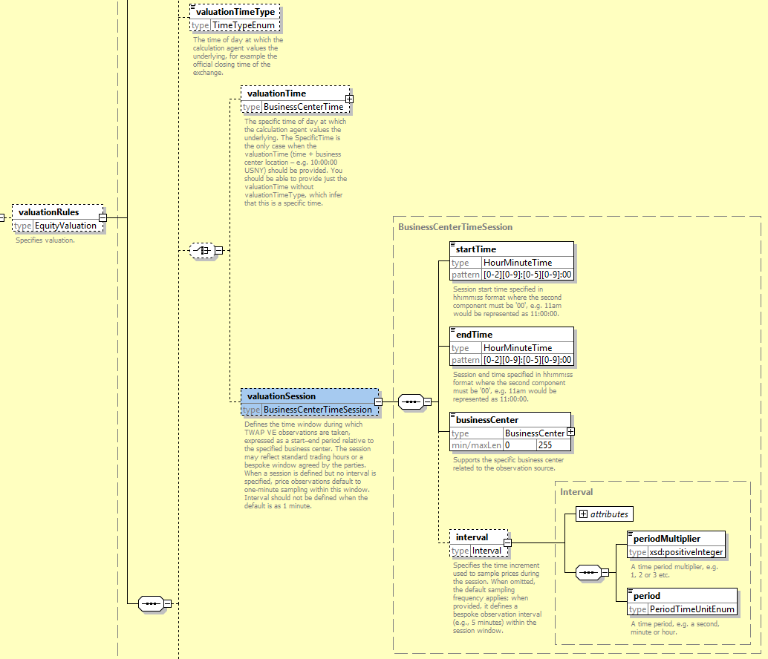
Based on Harry’s recommendation – valuationTime and valuationSession is now as a choice where only one can be selected when required. Interval period is now restricted to show only hour/minute/second.
Industry experts should assess if SpecificTime matches valuationSession, or whether it is necessary to assign a distinct value such as TimeSession.
- Include element informationSource to valuationRules for easier representation.
- Example 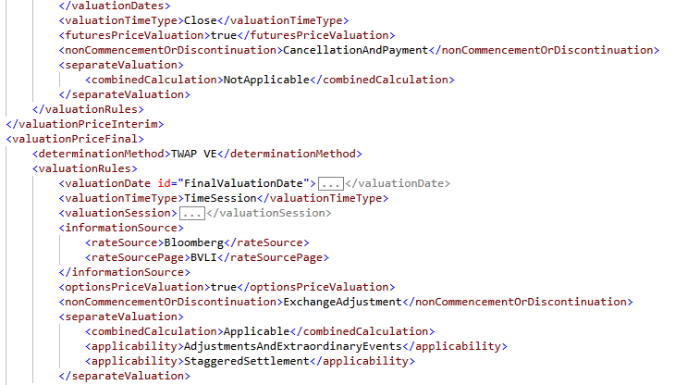

Applicability Condition
These price mechanisms are relevant to share transactions only, i.e where underlyer=singleUnderlier=equity, or basketConstituent=equity
These will be reflected as new business validation rules.

Separate Valuation/Combined Calculation

Equity Definitions VE Confirmation extract:
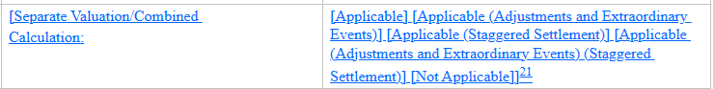
The “separate valuation / combined calculation” provisions are relevant to basket transactions:
- The provisions allow the calculation agent to value basket constituents separately when certain components cannot be valued on a given valuation date (e.g. local holiday or market disruption).
- They also cover:
  - Whether adjustments and extraordinary events are applied per component, and
  - Whether staggered settlement may be used (e.g. settling cashflows in respect of some components earlier than others).

FpML schema:
Node representation of this optional attribute
Under ValuationRules seems to be the most appropriate place.

Implemented in FpML
XAPWG recommends that this feature should be Applicable and Not Applicable as choice. Applicable choice then can be specified with added Applicability condition(s) under optional recurring element applicability –
- AdjustmentsAndExtraordinaryEvents
- StaggeredSettlement
Based on Harry’s recommendation attributes are grouped into a complex type – “SeparateValuation”
- Add valuationRules (of type EquityValuation) / separateValuation/combinedCalculation
- Add valuationRules (of type EquityValuation) / separateValuation/applicability
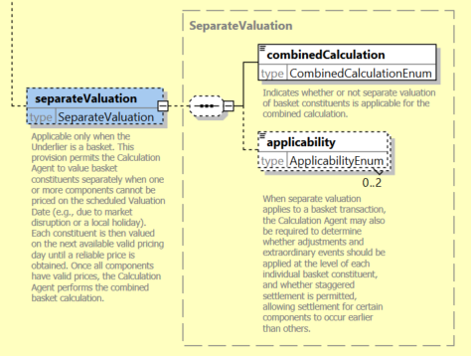

Valid Values/Enumerations:
Following 2 enumerated values:
separateValuation/combinedCalculation
- Applicable
- NotApplicable
separateValuation/applicability – This attribute can be specified up to twice to represent both values.
- AdjustmentsAndExtraordinaryEvents
- StaggeredSettlement
Example: 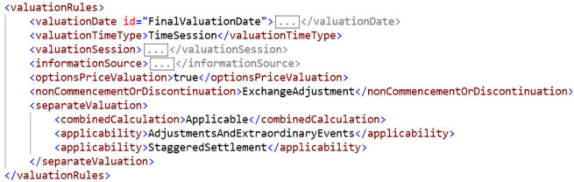

Applicability Condition
These fields and elections are relevant to basket transactions only (regardless of the underlier type), i.e. underlyer=basket
separateValuationApplicability can only be specified when separateValuationCombinedCalculation is set to be Applicable.

Benchmark Provisions

Equity Definitions VE Confirmation extract:
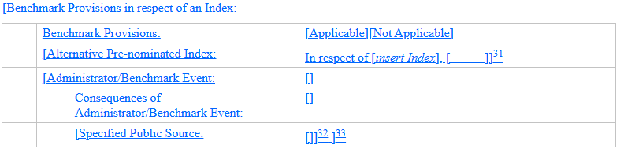
These provisions address compliance with EU Benchmarks Regulation (BMR) and similar global regimes governing the use of benchmarks in financial instruments.
High-level explanation:
- These provisions cover scenarios where the reference index is no longer compliant or otherwise affected by benchmark regulation.
- By electing “benchmark provisions applicable” in the confirmation, parties can rely on predefined consequences specified in the definitions.
- Ability to specify an alternative pre-nominated index, to which the transaction would switch if a benchmark event occurred.
- Equity Definitions VE also allows for bespoke “administrative benchmark events” and free-text consequences, but these are highly customised.

FpML schema:
Node representation of this optional attribute
- Add equitySwapTransactionSupplement / benchmarkProvisions
- Add equitySwapTransactionSupplement / alternativePreNominatedIndex
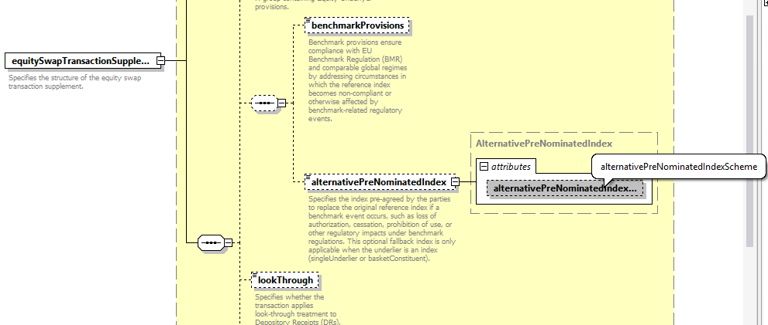

Valid Values/Enumerations:
For, benchmarkProvisions
- Applicable
- Not Applicable
Example: 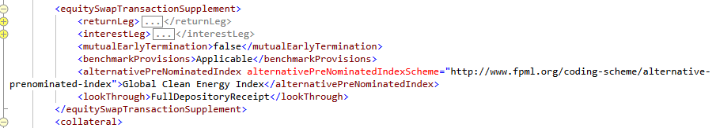

Applicability Condition
Can only be used for index transactions.
underlyer=singleUnderlier=index, or basketConstituent=index

Full DR Lookthrough and Partial DR Lookthrough provisions

Equity Definitions VE Confirmation extract:
Where the transaction references Depository Receipts (DRs) such as ADRs or GDRs, the parties may elect:
- Full Look-Through – used in transactions where the parties may be hedging in the shared underlying the DRs and require the terms of the transaction to look through to events in respect of the underlying shares.
- Partial Look-Through – as above but with a narrower scope of circumstances in which the transaction will look through to events affecting the shares underlying the DRs.
High-level explanation:
- Look-Through ensures that corporate actions, dividends, voting adjustments, and valuation mechanics reflect the true underlying share where economically intended.

FpML schema:
Node representation of this optional attribute

Implemented in FpML
- Add equitySwapTransactionSupplement / lookThrough
XAPWG agreed on the highlighted attribute among the following choices –
- depositoryReceiptLookThrough
- lookThrough

Propose to add them in similar places to the Index Benchmark provisions above extraordinaryEvents
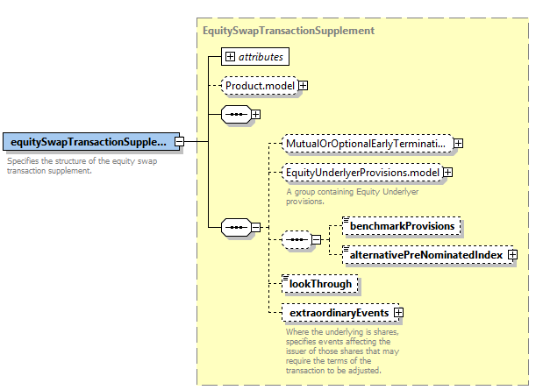

Valid Values/Enumerations:
- FullDepositoryReceipt
- PartialDepositoryReceipt
Example: 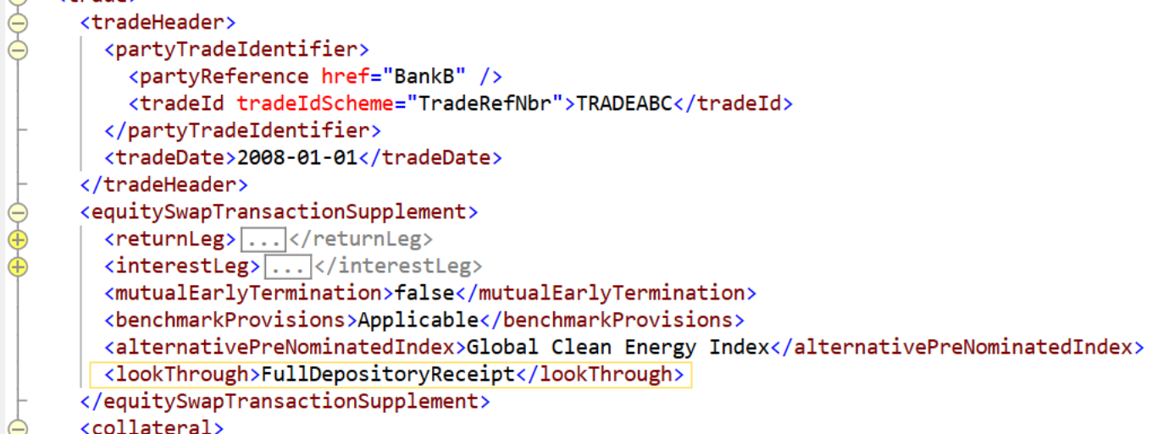

Applicability Condition
These fields/elections are relevant to share transactions only.
underlyer=singleUnderlier=equity, or basketConstituent=equity

Appendix
Attached are schema files and sample examples.
